Inheritance assignment

I have included a program that has our road_vehicle inheritance layout

The attached page is a small ‘flowchart’ that describes the inheritance

We (actually you) have two problems to address in this assignment

1. Create a class named Hybrid
   1. Inherits from both gasCar and electricCar
   2. Has no data items
   3. Only one member function named show

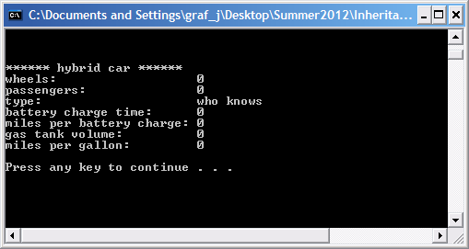

When you add the code for the hybrid class and compile, you will get an ambiguity error. The answer for this problem is on page 352 of the text

1. Create constructors for each derived class that will pass up information to initialize all fields in the base classes. I would suggest that you
   1. Write a ‘default’ constructor for each class
   2. Write a constructor for each class that only initializes that classes data items
   3. Road_Vehicle and ElectricCar are examples of steps a and b
   4. Create a constructor for each class that will accept enough variables such that the derived class can call its base classes constructors (not the default) and initialize all fields
   5. Again – for step d start at the top (Road_Vehicle)